|  |
| --- |
| **Machine Learning**  **PHW2** |



|  |  |  |  |
| --- | --- | --- | --- |
| **제출일** | **2022.9.27** | **전공** | **소프트웨어학과** |
| **과목명** | **머신러닝** | **이름** | **안해빈, 이지민,**  **임윤수, 윤주은** |

# Contents of Table

# 1. Objective

# 2. End-To-End Process

# 2-1. Data Inspection, Data Preparation

# 2-2 Analysis Algorithms, Evaluation + Choose Parameters

# 3. Function - "AutoML"

# 4. Main Program

# 5. Conclusion

# 1. Objective

# We would like to show different combinations of algorithms to analyze a dataset We will create a program structure with a single major function “AutoML” that will automatically run different combinations of the following :

# Data Scaling, Data Encoding

# Various Clustering Algorithms

# Various quality measuring tools

# Various values of parameters and hyperparameters

# Various subsets of the features of the dataset

# 2. End-to-End Process

# 2.1 Dataset

# source: <https://www.kaggle.com/camnugent/california-housing-prices>

# Dataset Inspection

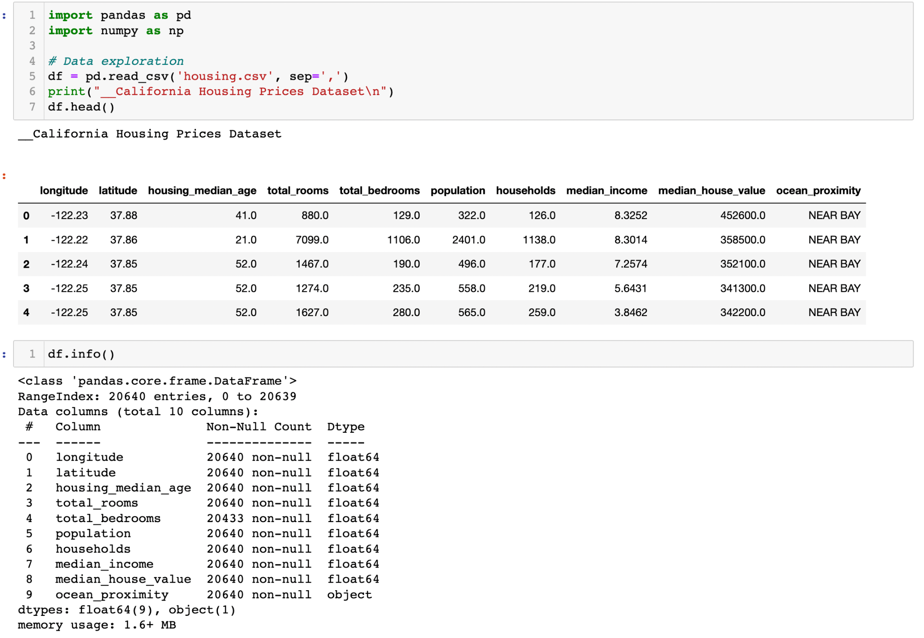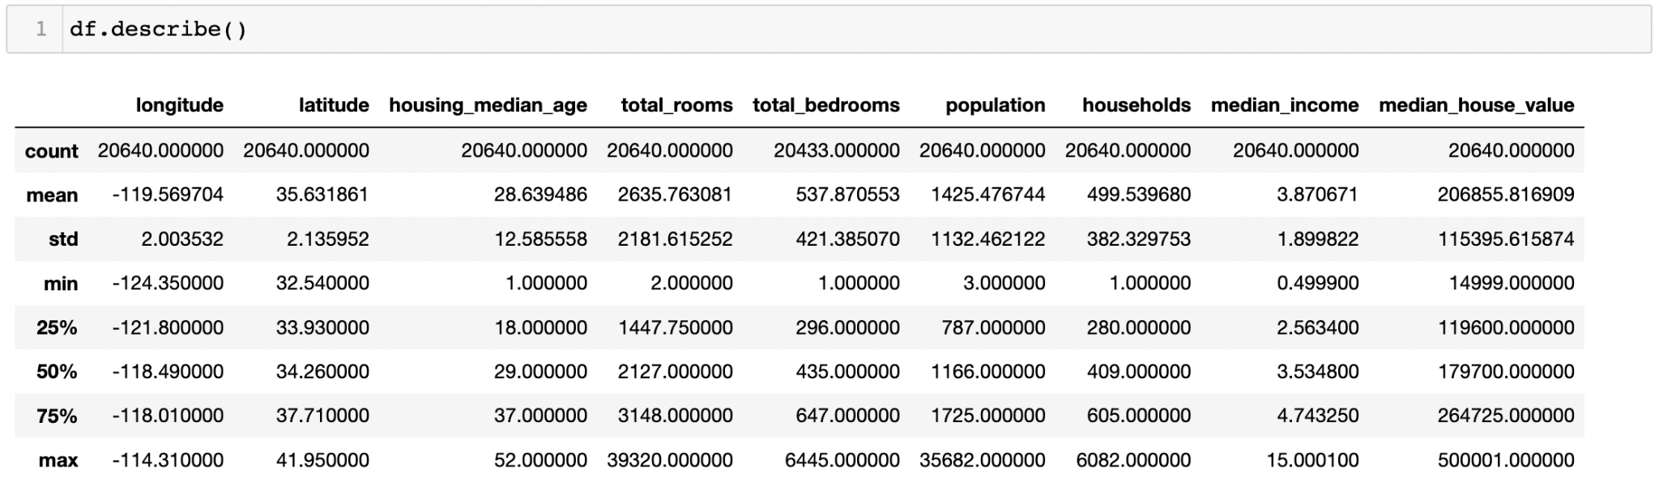

**Data Preprocessing**

* Drop target value : "median_house_value"
* Clean dirty data

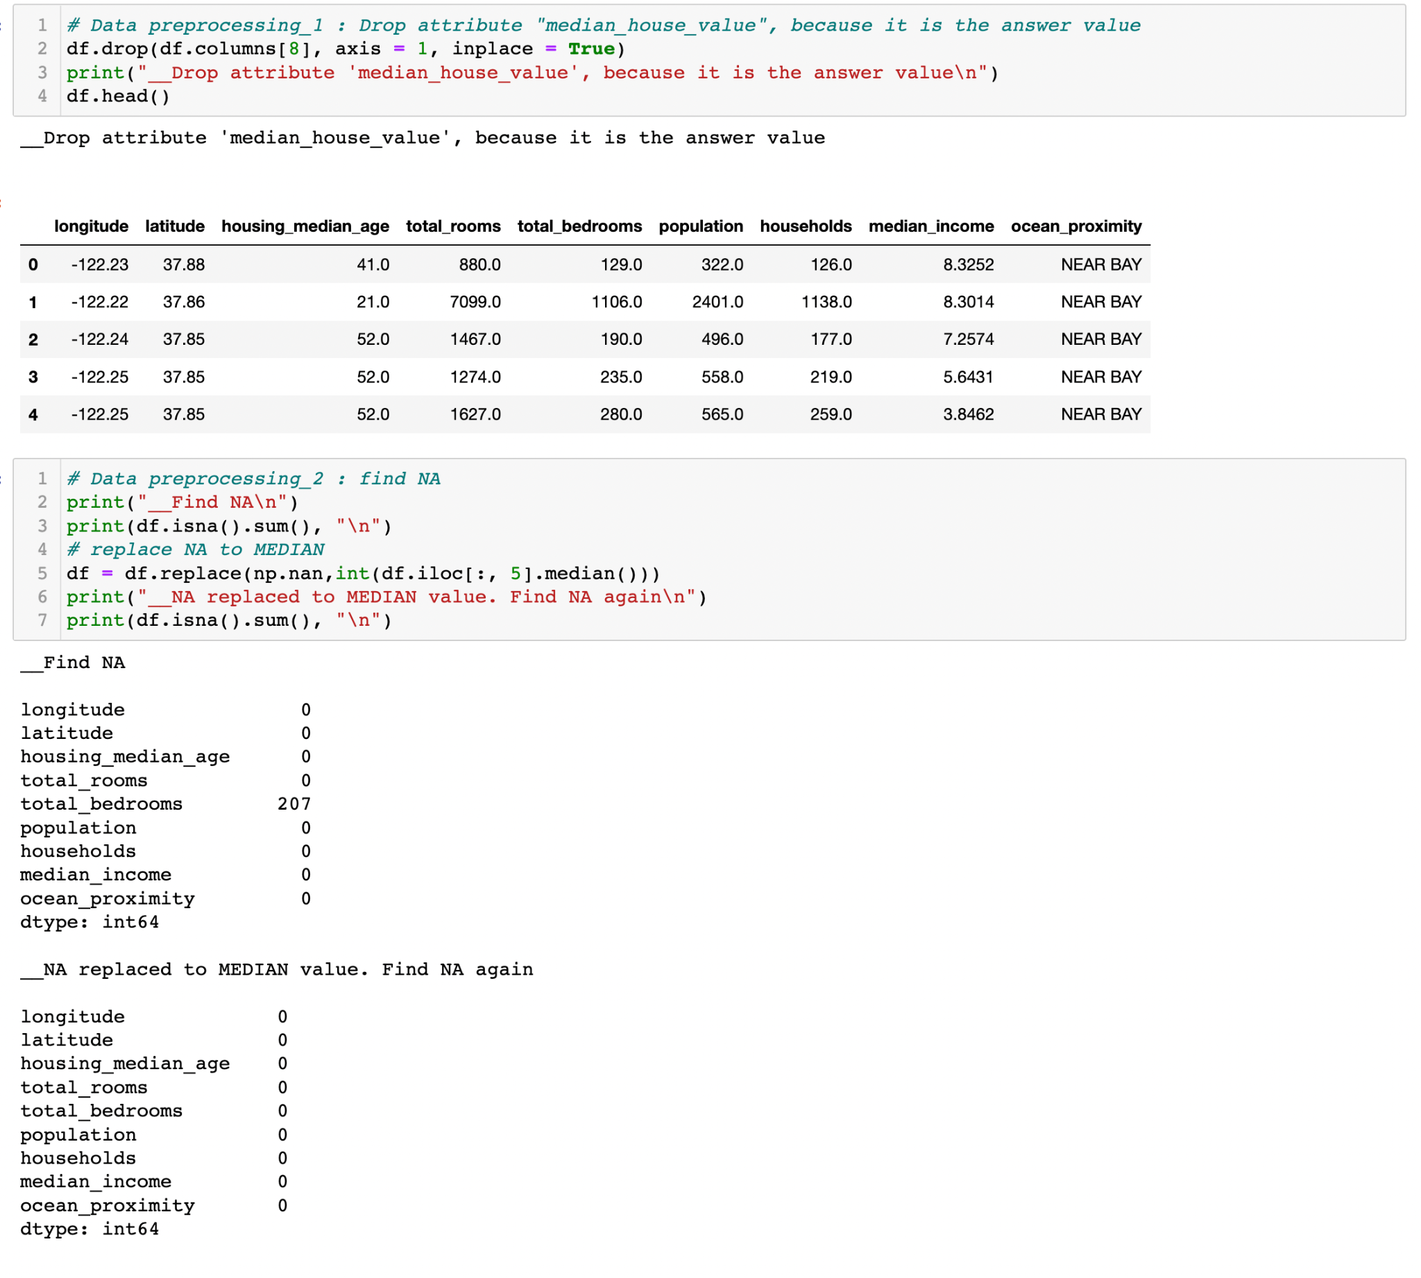

# 2.2 Analysis Algorithms, Evaluation

### Algorithm:K-means, EM(GMM) ,CLARANS, DBSCAN, Meanshift Scaler: StandardScaler, RobustScaler, MinMaxScaler, MaxAbsScaler Encoder : LabelEncoder, OneHotEncoder

**Data encoding & scaling process**

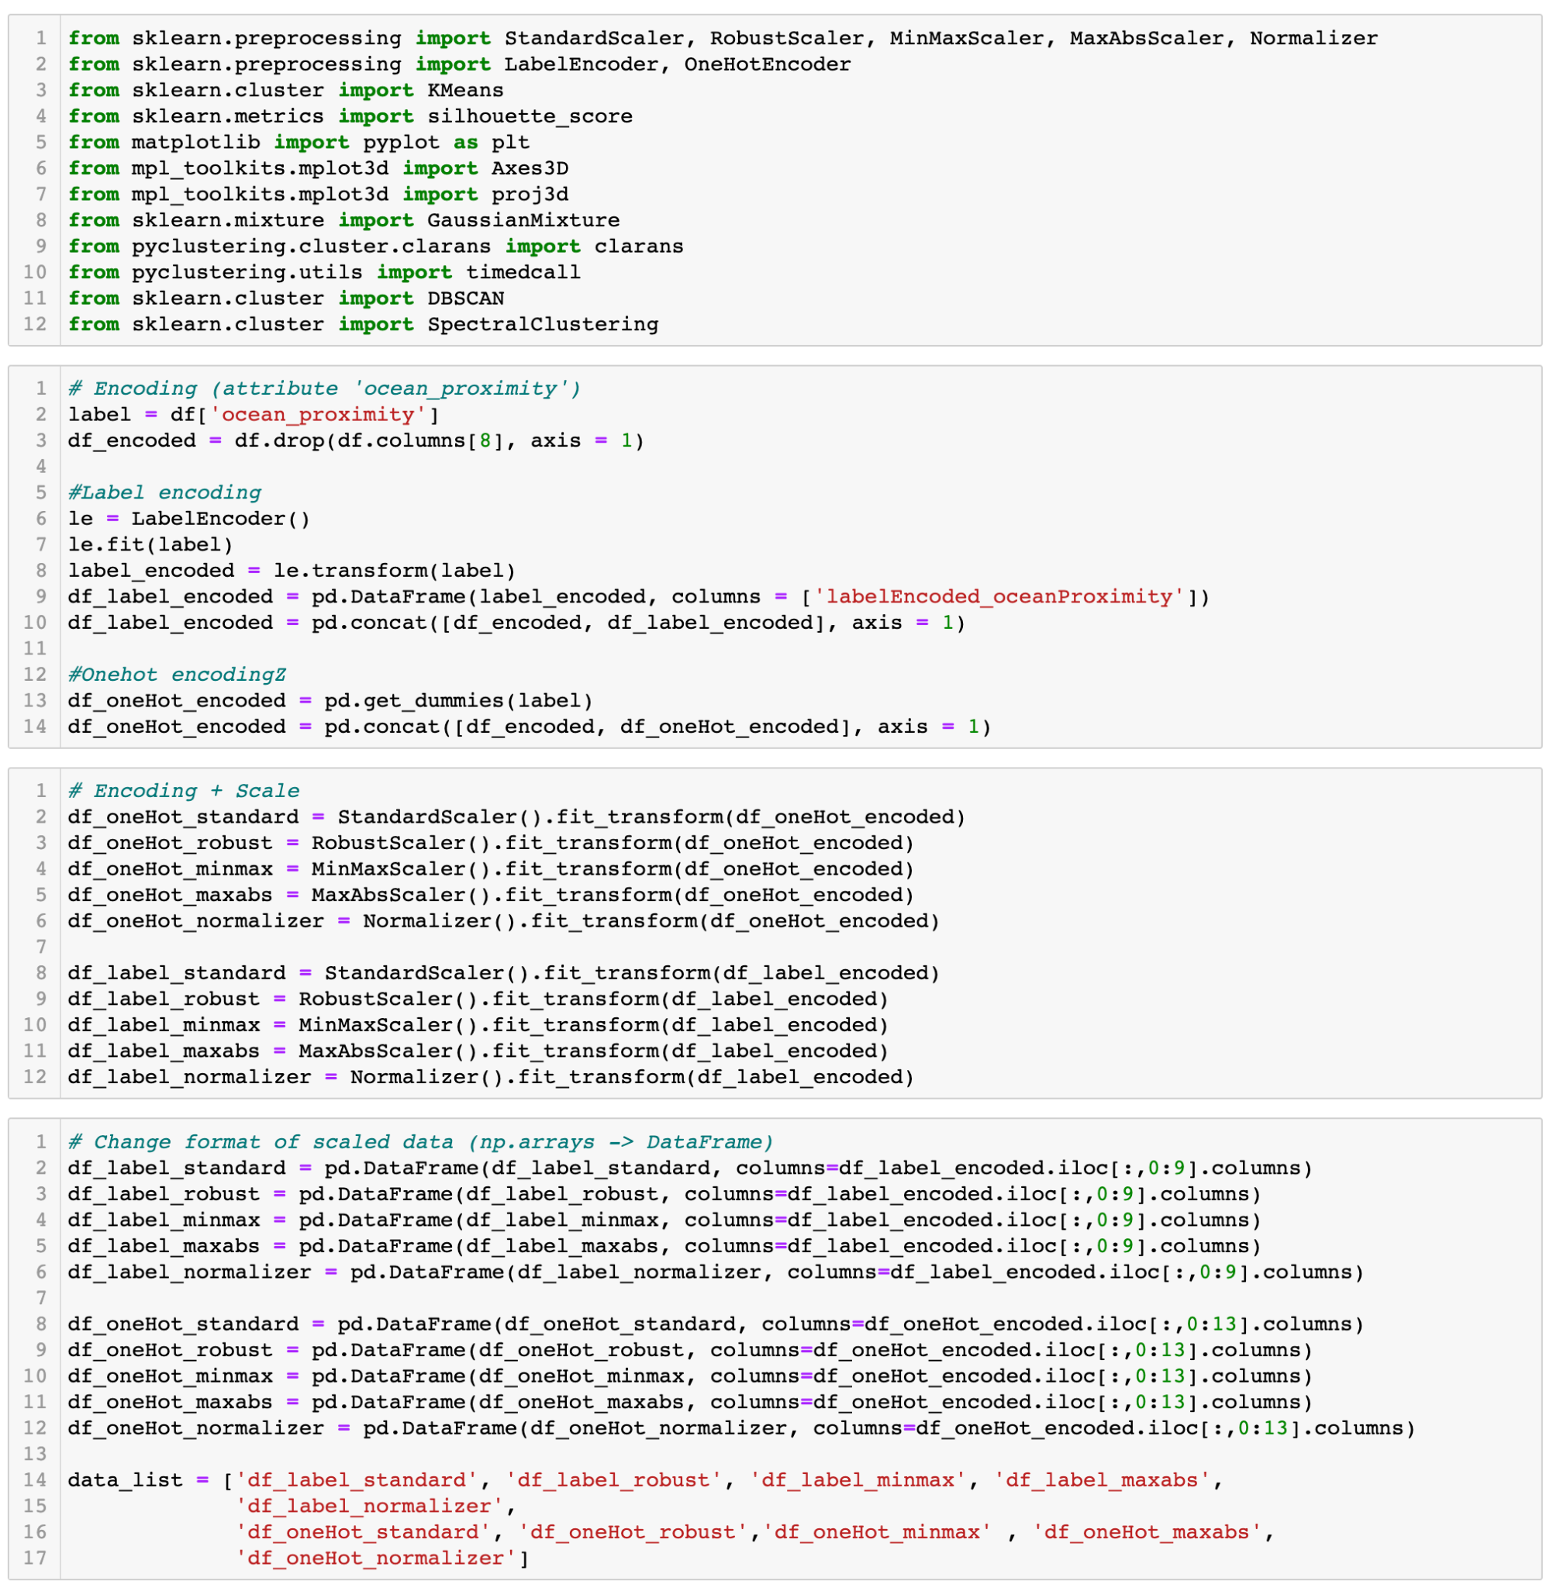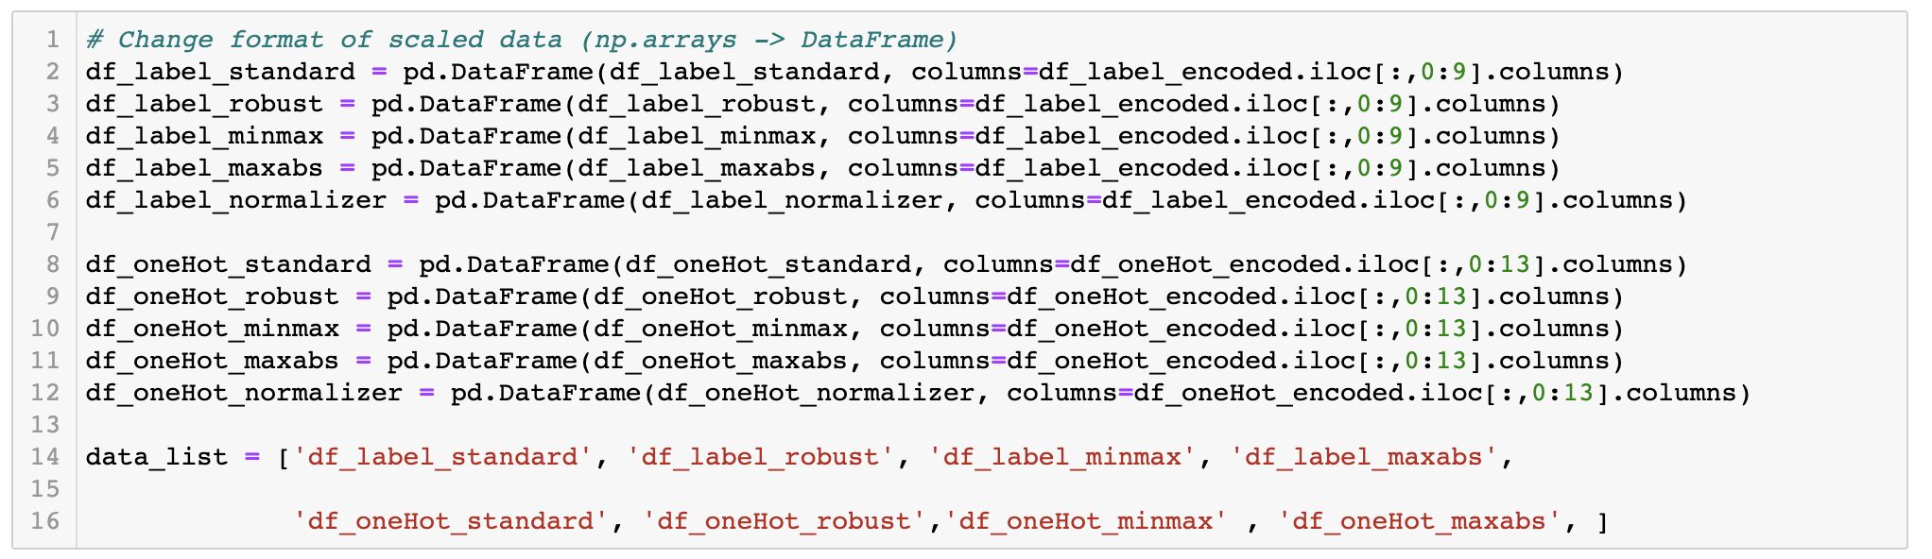

# Explore the best encoder, scaler, in K-Means clustering. (K was calculated as 4, 5, and 6 respectively)

# 

# The best combination: Encoding method: OneHotEncoder Scaling method: RobustScaler

# In the above results, when k=5, the silhouette score in the case of using One Hot Encoder and Robust scaling was the best. However, the best parameter is determined to be K=6, One Hot Encoder, and Robust scaling because the silhouette score is good on average when K=6.

**Average Quantile comparison score(purity_score): 0.3424903100775194**

# Explore the best encoder, scaler, in GMM clustering. (K was calculated as 4, 5, and 6 respectively)

# 

# 

# The best combination: Encoding method: OneHotEncoder Scaling method: RobustScaler

# In the above results, when k=5, the silhouette score in the case of using One Hot Encoder and Robust scaling was the best. However, the best parameter is determined to be K=6, One Hot Encoder, and Robust scaling because the silhouette score is good on average when K=6.

**Average Quantile comparison score(purity_score): 0.3902616227906976**

# Explore the best encoder, scaler, in DBSCAN clustering. (K was calculated as 4, 5, and 6 respectively)

# 

# The best combination: Epsilon: 0.4 Threshold: 15 Encoding method: LabelEncoder Scaling method: StandardScaler

# In the above results, when Eplsion = 0.4, Threshold = 15, the silhouette score in the case of using Label encoder and Standard scaling was the best.

# 

# Explore the best encoder, scaler, in CLARANS clustering. (K was calculated as 4, 5, and 6 respectively)

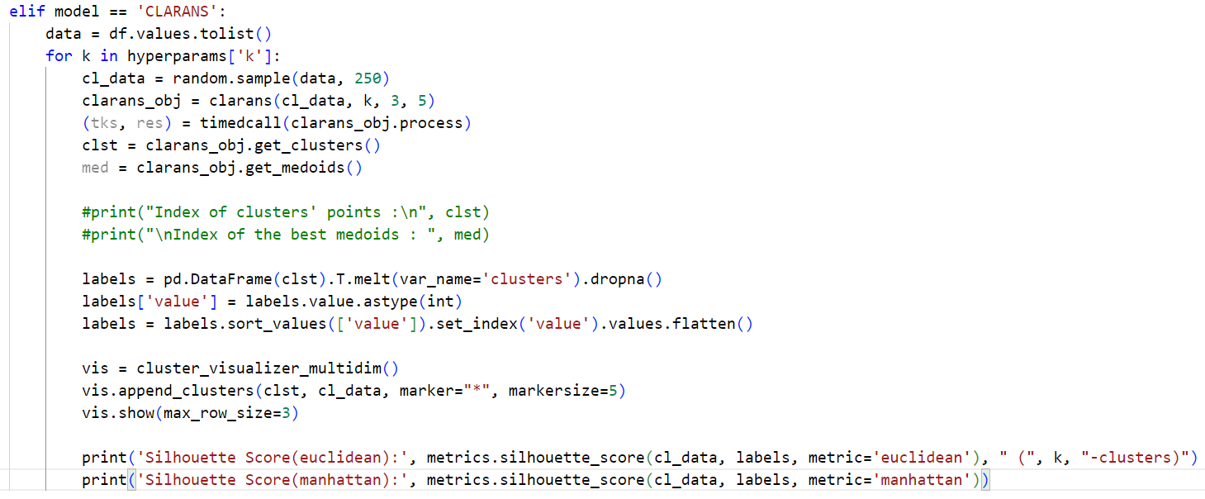

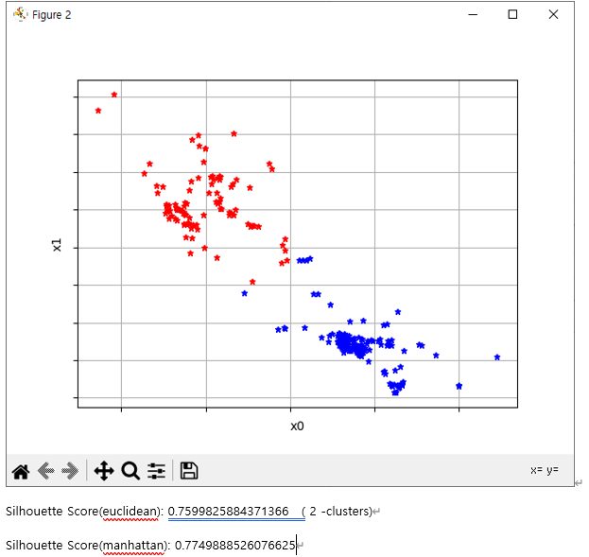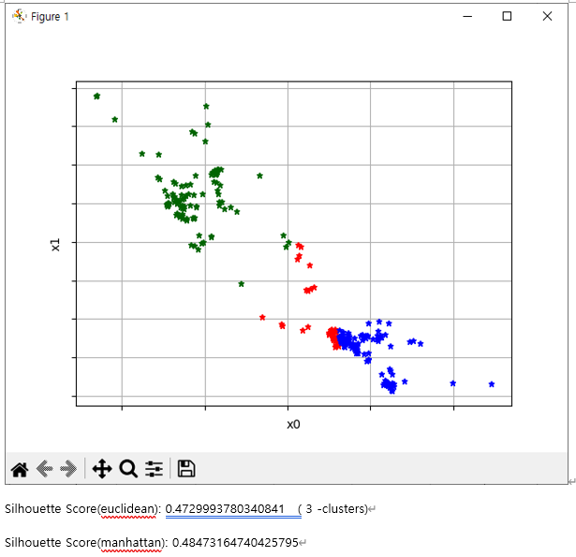

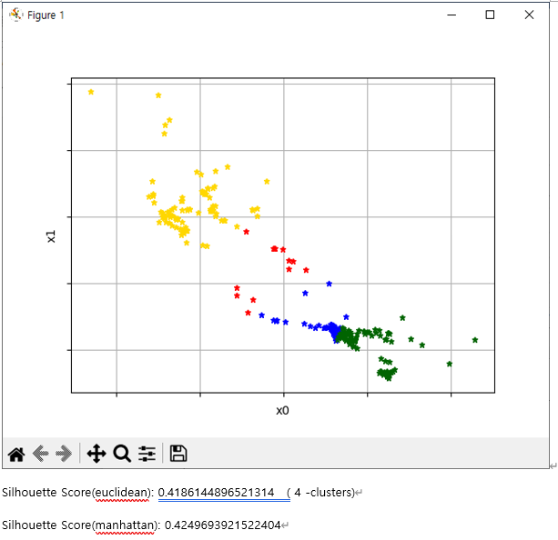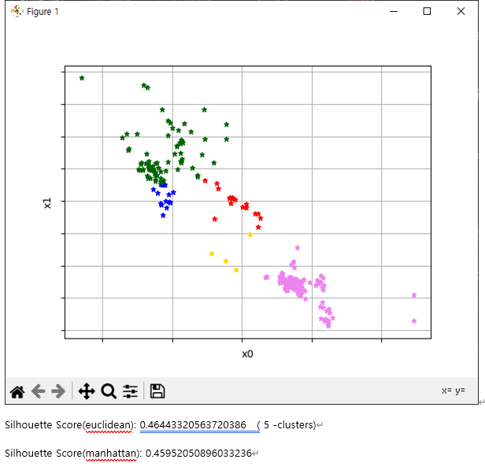

# The best combination: Encoding method: OneHotEncoder Scaling method: StandardScaler

# In the above results, when k=5, the silhouette score in the case of using One Hot Encoder and Stand scaling was the best. (We used only two attributes 'longitude', 'latitude')

# Explore the best encoder, scaler, in MeanShift clustering. (K was calculated as 4, 5, and 6 respectively)

# 

# The best combination: Encoding method: LabelEncoder Scaling method: StandardScaler

# In the above results, when bandwidth = 20, the silhouette score in the case of using Label Encoder and Standard scaling was the best. (We used only two attributes 'longitude', 'latitude')

AutoML

### A function AutoML is an all-in-one classifier function. It Automatically runs different combinations of the below :

* Data Scaling, Data Encoding
* Various Clustering Algorithms
* Various quality measuring tools
* Various values of parameters and hyperparameters
* Various subsets of the features of the dataset

**Attributes:**

### encoder:

List of default encoders that are supported in the AutoML function.  
 Currently, ['LabelEncoder()', 'OneHotEncoder()'] supported

### scaler:

List of default scalers that are supported in the AutoML function.  
 Currently, ['StandardScaler()', 'MinMaxScaler()', 'RobustScaler()', 'MaxAbsScaler()']  
 is supported

### model:

List of default clustering models that are supported in the AutoML function.  
 Currently ['KMeans', 'GMM', 'CLARANS', 'DBSCAN', MeanShift] supported

**(KMeans)K: int, default = 6**

the hyperparameter for KMeans Clustering.

**(GMM)K: int, default = 6**

the hyperparameter for GMM Clustering.

**(DBSCAN)eps: int, default = 0.4**

the hyperparameter for **DBSCAN** Clustering.

**(CLARANS)K:int, default = 5**

the hyperparameter for **CLARANS** Clustering.

**(MeanShift)N:int, default = 20**

the hyperparameter for **MeanShift** Clustering.

**Parameters:**

**scaler_list: list, default=None**

if None, then the function returns nothing.

Supported Scaler = ['StandardScaler()', 'MinMaxScaler()', 'RobustScaler()', 'MaxAbsScaler()'']

Only supported arguments are available. Else, error returned

### encoder_list: list, default=None

if None, then the function returns nothing.

Supported Encoder = ['LabelEncoder()', 'OneHotEncoder()']

Only supported arguments are available. Else, error returned

### model_list: list, default=None

if None, then the function returns nothing.

Supported Model = ['KMeans', 'GMM', 'CLARANS', 'DBSCAN', 'Spectral']

Only supported arguments are available. Else, error returned

### training_dataset: dataframe, default=None

if None, then the function returns error

# 

|  |
| --- |
| def autoML(encoder_list, scaler_list, model_list, df, y):      # Set supported scalers, encofders and models      encoder = ['LabelEncoder()', 'OneHotEncoder()']      scaler = ['StandardScaler()', 'MinMaxScaler()', 'RobustScaler()', 'MaxAbsScaler()']      model = ['KMeans', 'GMM', 'CLARANS', 'DBSCAN', 'MeanShift']      # Verify that the autoML function supports the scaler, encoder, and model entered as a function parameter.      notspt = False;      for e in encoder_list:          if e not in encoder:              print("The entered encoder", e, "is not supported in the autoML function.\n")              notspt = True;      for s in scaler_list:          if s not in scaler:              print("The entered scaler", s, "is not supported in the autoML function.\n")              notspt = True;      for m in model_list:          if m not in model:              print("The entered model", m, "is not supported in the autoML function.\n")              notspt = True;      if notspt:          print("Try again with supported parameters.\n")          return      for e in encoder_list:          # Encoding (attribute 'ocean_proximity')          if 'ocean_proximity' in df.columns:              label = df['ocean_proximity']              df_encoded = df.drop(labels='ocean_proximity', axis=1)              if e == 'LabelEncoder()':                  le = LabelEncoder()                  le.fit(label)                  label_encoded = le.transform(label)                  df_label_encoded = pd.DataFrame(label_encoded, columns=['labelEncoded_oceanProximity'])                  df_encoded = pd.concat([df_encoded, df_label_encoded], axis=1)                  print("__", e, " Finished.")              if e == 'OneHotEncoder()':                  df_oneHot_encoded = pd.get_dummies(label)                  df_encoded = pd.concat([df_encoded, df_oneHot_encoded], axis=1)                  print("__", e, " Finished.")          else:              df_encoded = df          # Scale          for s in scaler_list:              # Scale              if s == 'StandardScaler()':                  df_scaled = StandardScaler().fit_transform(df_encoded)              if s == 'RobustScaler()':                  df_sclaed = RobustScaler().fit_transform(df_encoded)              if s == 'MinMaxScaler()':                  df_scaled = MinMaxScaler().fit_transform(df_encoded)              if s == 'MaxAbsScaler()':                  df_scaled = MaxAbsScaler().fit_transform(df_encoded)              # Change format of scaled data (np.arrays -> DataFrame)              if e == 'LabelEncoder()':                  cols = df_scaled.shape[1]                  df_scaled = pd.DataFrame(df_scaled, columns=df_encoded.iloc[:, 0:cols].columns)              if e == 'OneHotEncoder()':                  cols = df_scaled.shape[1]                  df_scaled = pd.DataFrame(df_scaled, columns=df_encoded.iloc[:, 0:cols].columns)              for m in model_list:                  # Clustering                  # K-Means                  if m == 'KMeans':                      distortions = []                      K = 6                      clust_model = KMeans(n_clusters=K, random_state=42, algorithm='auto')                      clust_model.fit(df_scaled)                      centers = clust_model.cluster_centers_                      pred = clust_model.predict(df_scaled)                      df_clusted = df_scaled.copy()                      df_clusted['cluster'] = pred                      distortions.append(clust_model.inertia_)                      print("\n__Result of K-Means Clustering\n")                      print("Scaler : ", s, "Encoder : ", e)                      print("Column list : ", df.columns.to_list())                      # Silhouette score                      score = silhouette_score(df_scaled, pred, metric="euclidean")                      print("Silhouette Score:", score)                      print('Quantile comparison score(purity_score):', purity_score(y, pred))                      # Visualization                      fig = plt.figure(figsize=(8, 8))                      ax = fig.add_subplot(111, projection='3d')                      X = df_clusted                      ax.scatter(X.iloc[:, 0], X.iloc[:, 1], X.iloc[:, 2], c=X.cluster, s=10, cmap='rainbow', alpha=1)                      ax.scatter(centers[:, 0], centers[:, 1], centers[:, 2], c='black', marker='*')                      plt.show()                  # GMM                  if m == 'GMM':                      K = 6                      gmm = GaussianMixture(n_components=K, random_state=42)                      gmm.fit(df_scaled)                      gmm_cluster_labels = gmm.predict(df_scaled)                      df_clusted = df_scaled.copy()                      df_clusted['gmm_cluster'] = gmm_cluster_labels                      print("\n__Result of GMM Clustering\n")                      print("Scaler : ", s, "Encoder : ", e)                      print("Column list : ", df.columns.to_list())                      # Silhouette score                      score = silhouette_score(df_scaled, gmm_cluster_labels, metric="euclidean")                      print("Silhouette Score:", score)                      print('Quantile comparison score(purity_score):', purity_score(y, gmm_cluster_labels))                      # Visualization                      fig = plt.figure(figsize=(8, 8))                      ax = fig.add_subplot(111, projection='3d')                      X = df_clusted                      ax.scatter(X.iloc[:, 0], X.iloc[:, 1], X.iloc[:, 2], c=X.gmm_cluster, s=10, cmap='rainbow', alpha=1)                      plt.show()                  # CLARANS                  if m == 'CLARANS':                      data = df.values.tolist()                      for k in range(2, 9):                          cl_data = random.sample(data, 250)                          clarans_obj = clarans(cl_data, k, 3, 5)                          (tks, res) = timedcall(clarans_obj.process)                          clst = clarans_obj.get_clusters()                          med = clarans_obj.get_medoids()                          #print("Index of clusters' points :\n", clst)                          #print("\nIndex of the best medoids : ", med)                          labels = pd.DataFrame(clst).T.melt(var_name='clusters').dropna()                          labels['value'] = labels.value.astype(int)                          labels = labels.sort_values(['value']).set_index('value').values.flatten()                          vis = cluster_visualizer_multidim()                          vis.append_clusters(clst, cl_data, marker="*", markersize=5)                          vis.show(max_row_size=3)                          print('Silhouette Score(euclidean):', metrics.silhouette_score(cl_data, labels, metric='euclidean'), " (", k, "-clusters)")                          print('Silhouette Score(manhattan):', metrics.silhouette_score(cl_data, labels, metric='manhattan'))                  # DBSCAN                  if m == 'DBSCAN':                      eps = 0.6                      threshold = 10                      model = DBSCAN(eps=eps, min_samples=threshold)                      model.fit(df_scaled)                      df_scaled['cluster'] = model.fit_predict(df_scaled)                      print("\n__Result of DBSCAN Clustering **Outlier = -1**\n")                      print("Scaler : ", s, "Encoder : ", e)                      print("Column list : ", df.columns.to_list())                      # Silhouette score                      score = silhouette_score(df_scaled, df_scaled['cluster'], metric="euclidean")                      print("Silhouette Score:", score)                      # Visualization                      fig = plt.figure(figsize=(8, 8))                      ax = fig.add_subplot(111, projection='3d')                      X = df_scaled                      ax.scatter(X.iloc[:, 0], X.iloc[:, 1], X.iloc[:, 2], c=X.cluster, s=10, cmap='rainbow', alpha=1)                      plt.show()                  # MeanShift                  if m == 'MeanShift':                      n = [10, 15, 20]                      for i in n:                          print(n)                          bandwidth = estimate_bandwidth(df, quantile=0.2, n_samples=i)                          ms = MeanShift(bandwidth=bandwidth)                          cluster = ms.fit(df)                          cluster_id = pd.DataFrame(cluster.labels_)                          d1 = pd.DataFrame()                          d1 = pd.concat([df, cluster_id], axis=1)                          d1.columns = [0, 1, "cluster"]                          # sns.scatterplot(d1[0], d1[1], hue=d1['cluster'], legend="full")                          # plt.title('Mean Shift with {} samples'.format(i))                          # plt.show()                          print('n_samples(estimate_bandwidth) = {}'.format(i))                          print('Silhouette Coefficient(euclidean): ',metrics.silhouette_score(d1.iloc[:, :-1], d1['cluster'], metric='euclidean'))                          print('Silhouette Coefficient(manhattan): ',metrics.silhouette_score(d1.iloc[:, :-1], d1['cluster'], metric='manhattan')) |

# 

# 4. Main Program(Use example)

|  |
| --- |
| import warnings  warnings.filterwarnings(action='ignore')  import pandas as pd  import numpy as np  import random  from sklearn.preprocessing import StandardScaler, RobustScaler, MinMaxScaler, MaxAbsScaler  from sklearn.preprocessing import LabelEncoder, OneHotEncoder  from sklearn.cluster import KMeans  from sklearn.metrics import silhouette_score  from sklearn.metrics import silhouette_samples  from matplotlib import pyplot as plt  from mpl_toolkits.mplot3d import Axes3D  from mpl_toolkits.mplot3d import proj3d  from sklearn.mixture import GaussianMixture  from pyclustering.cluster.clarans import clarans  from pyclustering.utils import timedcall  from sklearn.cluster import DBSCAN  from sklearn.cluster import MeanShift, estimate_bandwidth  from sklearn import metrics  from sklearn.metrics import *  from pyclustering.cluster import cluster_visualizer_multidim  def load_df(attList):      # Data exploration      df = pd.read_csv('housing.csv', sep=',')      print("__California Housing Prices Dataset\n")      # Drop the target value: "median_house_value"      df.drop(df.columns[8], axis=1, inplace=True)      print("__Drop attribute 'median_house_value', because it is the answer value\n")      # replace NA to MEDIAN      df = df.replace(np.nan, int(df.iloc[:, 5].median()))      print("__NA replaced to MEDIAN value.\n")      df2 = pd.DataFrame()      for i in attList:          if (i in df.columns):              df2[i] = df[i]      return df2  def purity_score(y_true, y_pred):      # Compute confusion matrix      contingency_matrix = metrics.cluster.contingency_matrix(y_true, y_pred)      # Return purity score      return np.sum(np.amax(contingency_matrix, axis=0)) / np.sum(contingency_matrix)  encoder_list = ['LabelEncoder()', 'OneHotEncoder()']  scaler_list_1 = ['StandardScaler()', 'MinMaxScaler()', 'RobustScaler()', 'MaxAbsScaler()']  model_list_1 = ['KMeans', 'GMM','DBSCAN']  scaler_list_2 = ['StandardScaler()', 'MinMaxScaler()', 'RobustScaler()', 'MaxAbsScaler()']  model_list_2 = ['CLARANS', 'MeanShift']  att_list1 = ['longitude', 'latitude', 'housing_median_age', 'total_rooms', 'total_bedrooms', 'population', 'households',               'median_income', 'median_house_value', 'ocean_proximity']  att_list2 = ['longitude', 'latitude', 'housing_median_age', 'total_rooms']  dataset_1 = load_df(att_list1)  dataset_2 = load_df(att_list2)  df = pd.read_csv('housing.csv', sep=',')  # Divide target value in 4 quantiles  quantiles = list(df['median_house_value'].quantile([0.25, 0.5, 0.75, 1.0]))  df.loc[df['median_house_value'] >= quantiles[0], 'quantiles'] = 1  df.loc[df['median_house_value'] >= quantiles[1], 'quantiles'] = 2  df.loc[df['median_house_value'] >= quantiles[2], 'quantiles'] = 3  df.loc[df['median_house_value'] >= quantiles[3], 'quantiles'] = 4  y = df['quantiles'].astype("category")  autoML(encoder_list, scaler_list_1, model_list_1, dataset_1, y)  autoML(encoder_list, scaler_list_2, model_list_2, dataset_2, y) |

**Full execute screenshots**

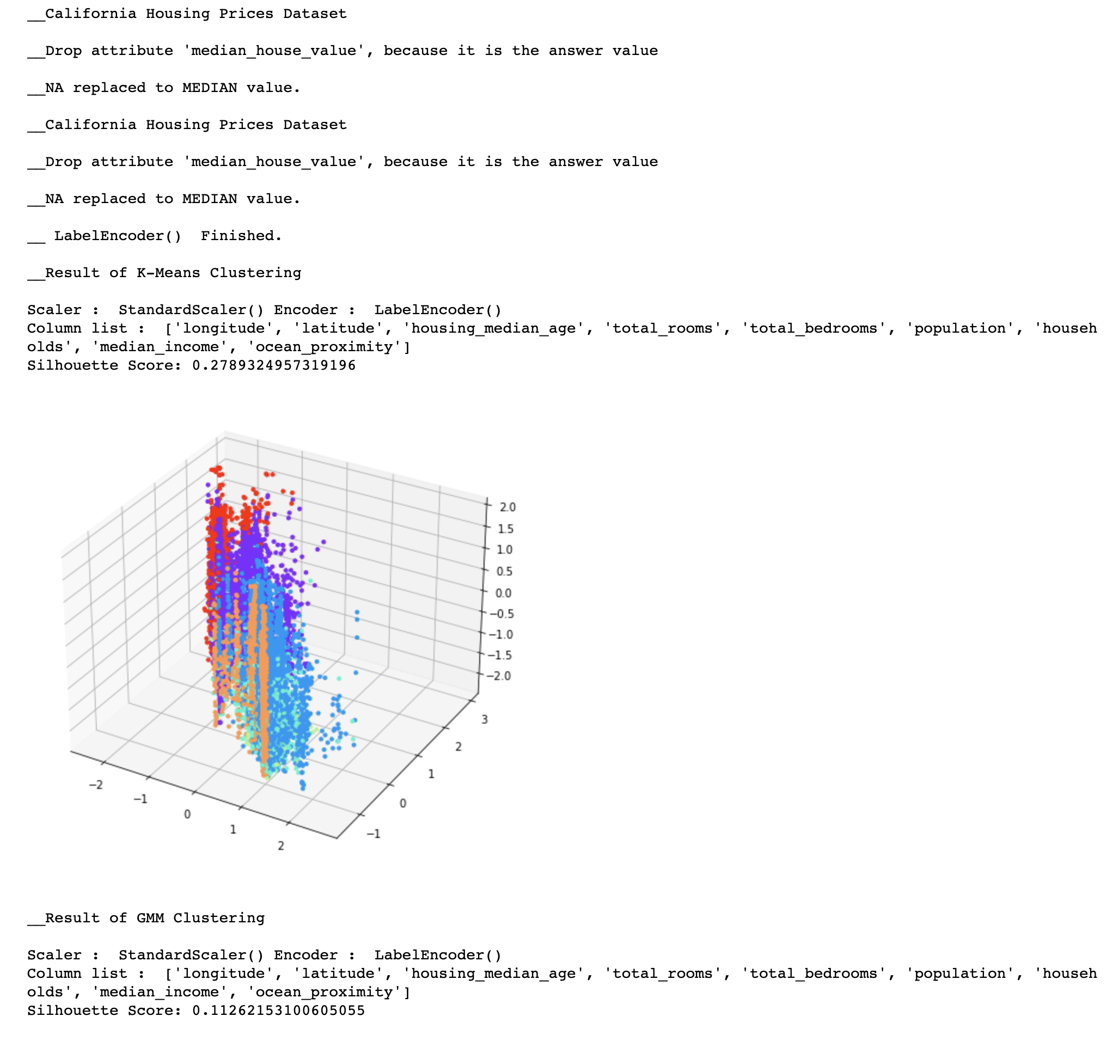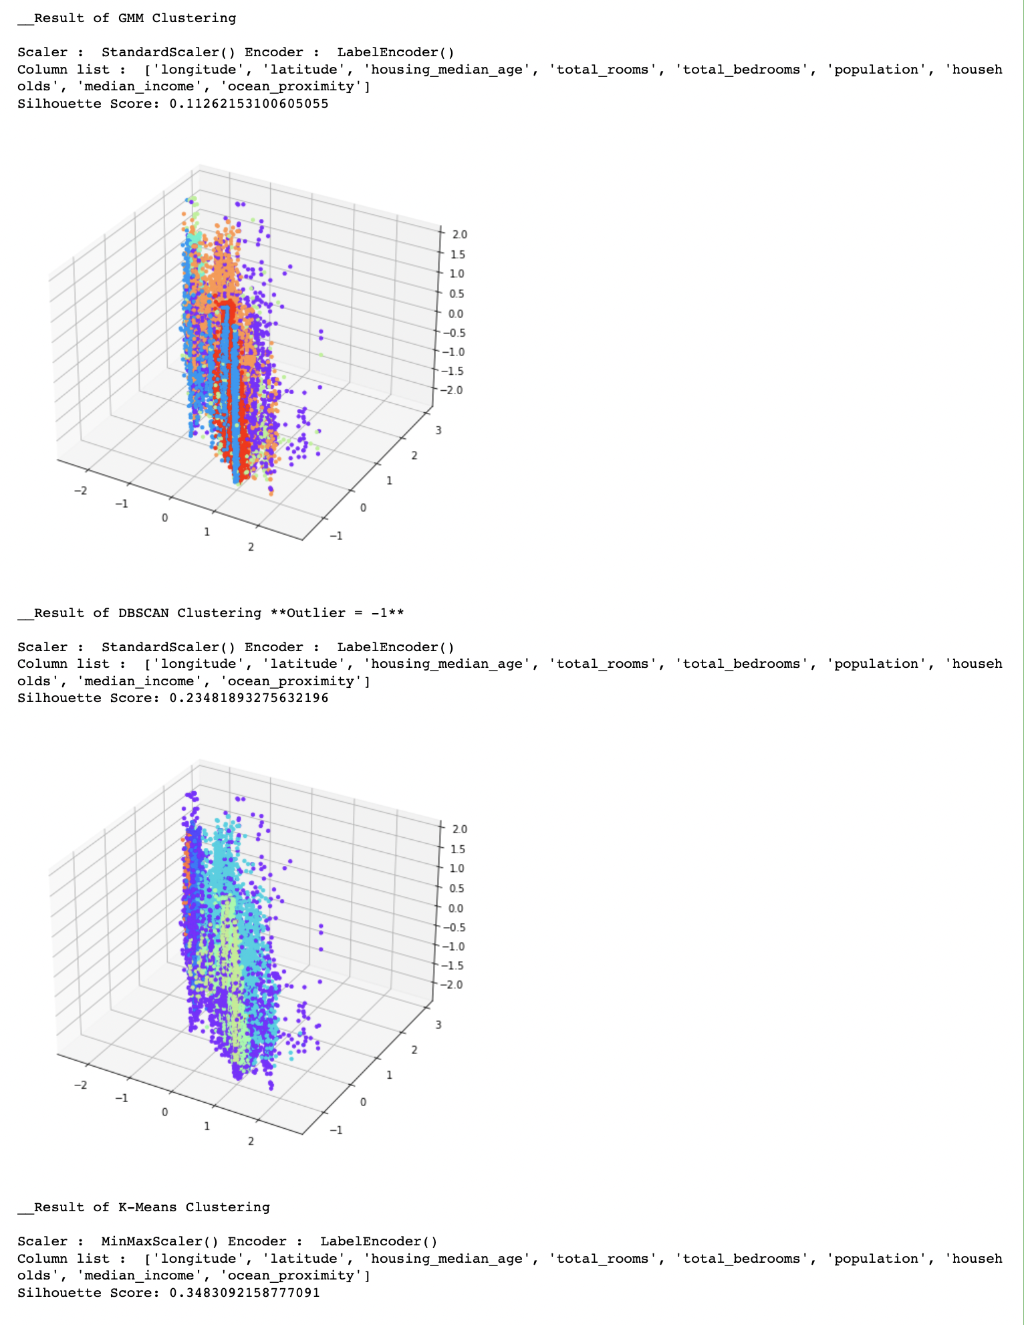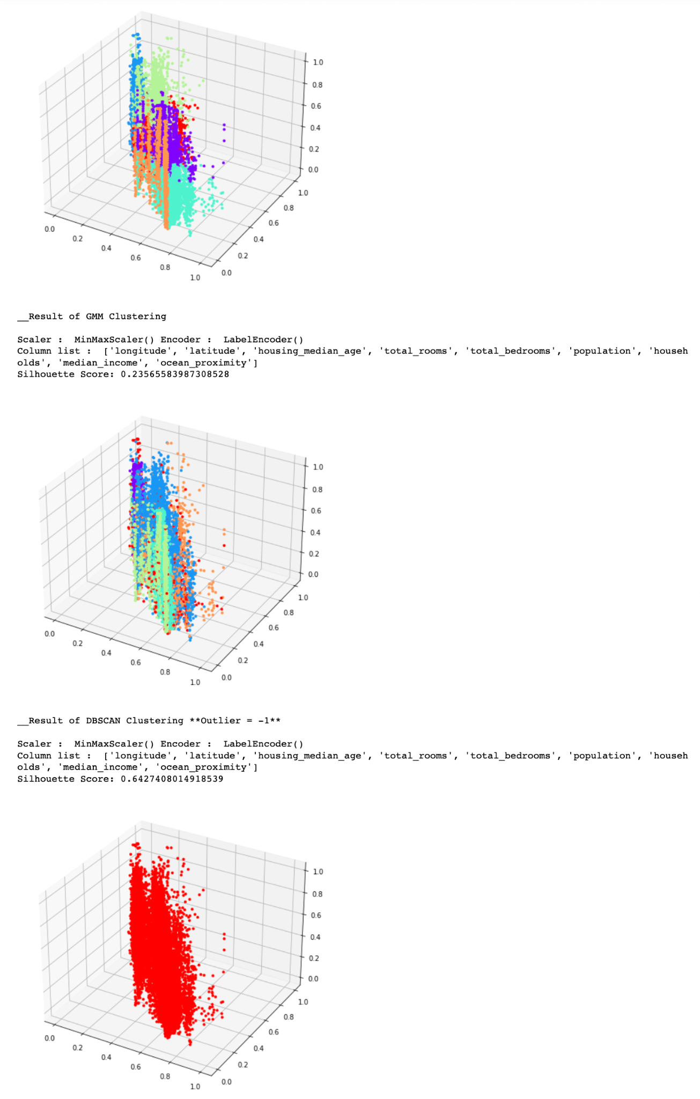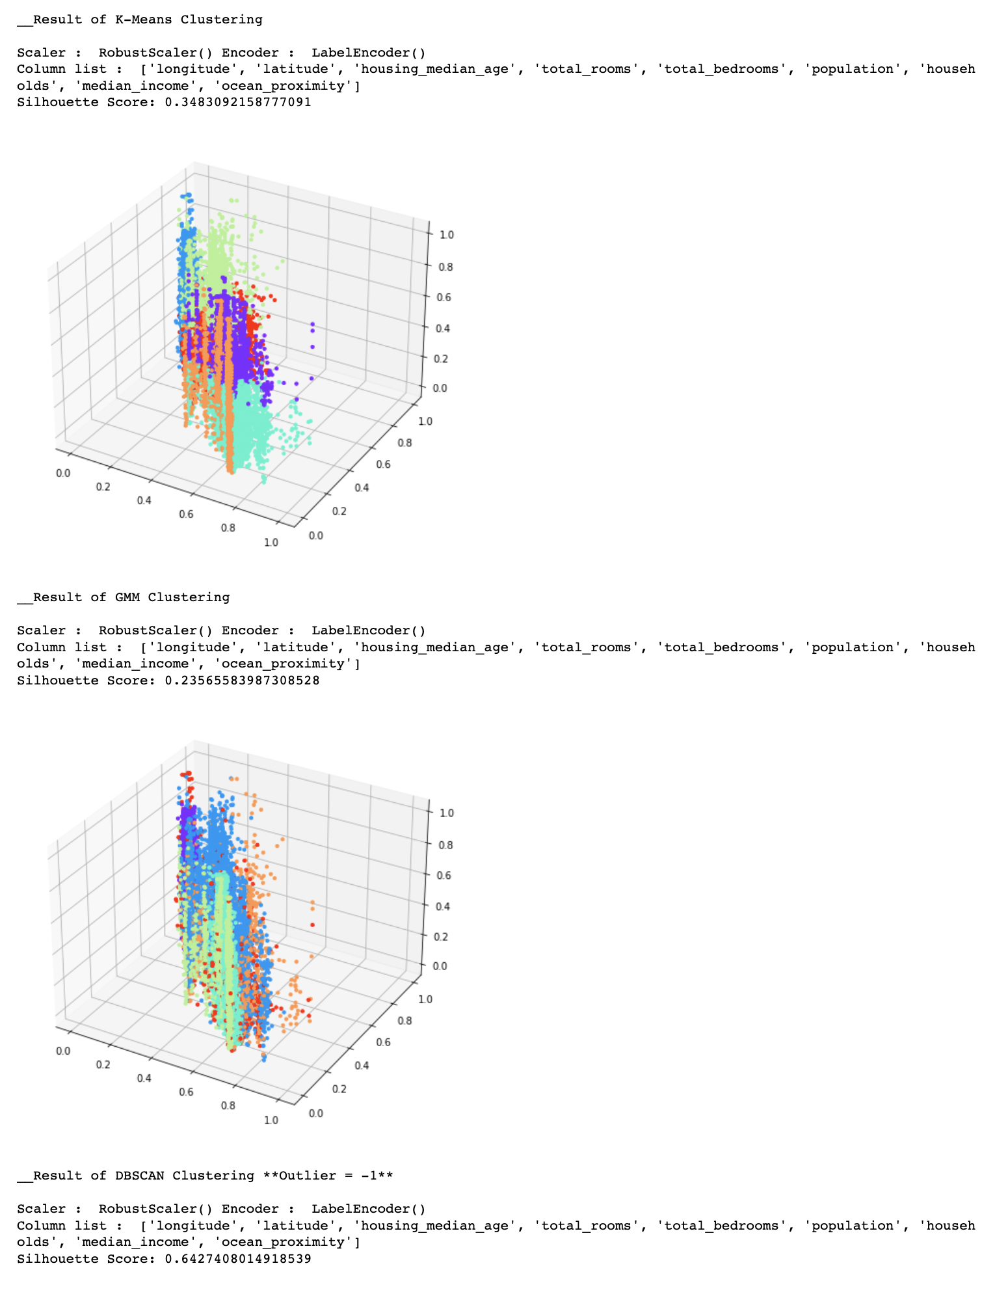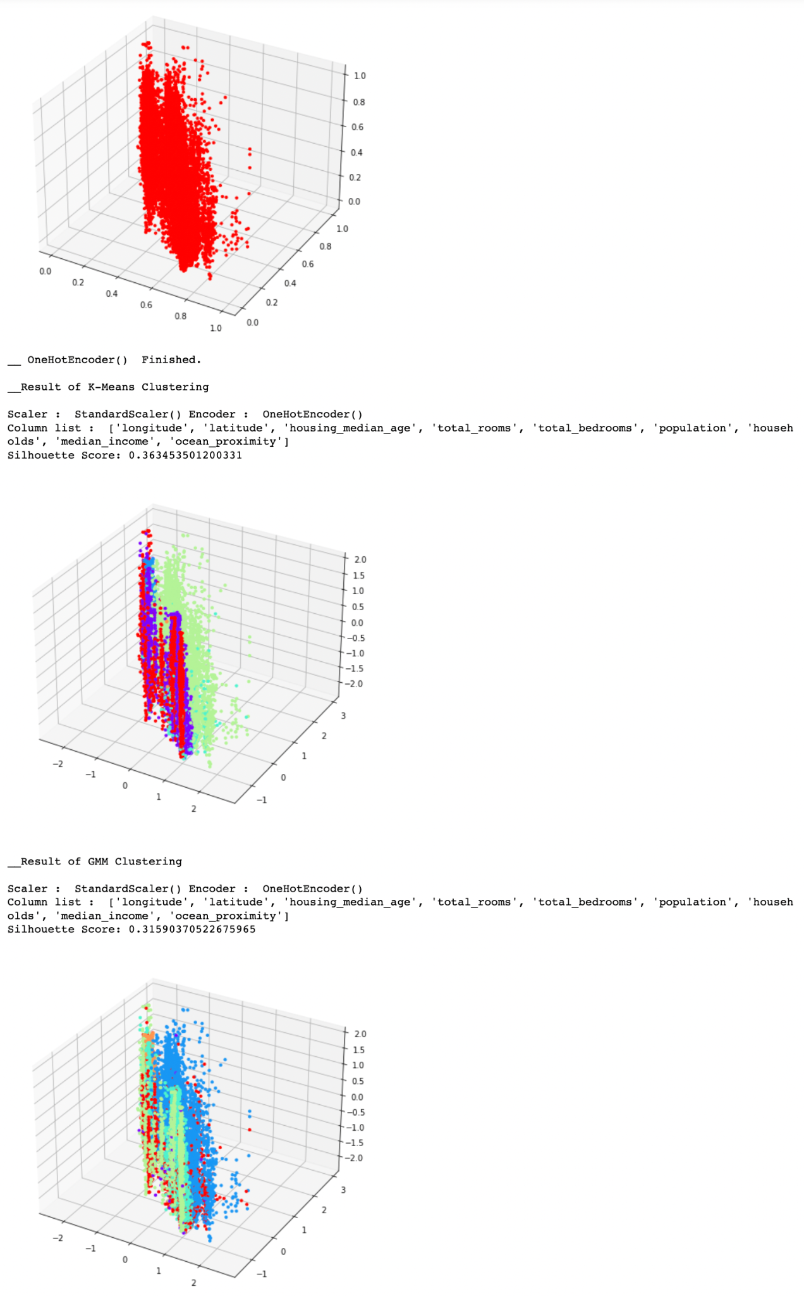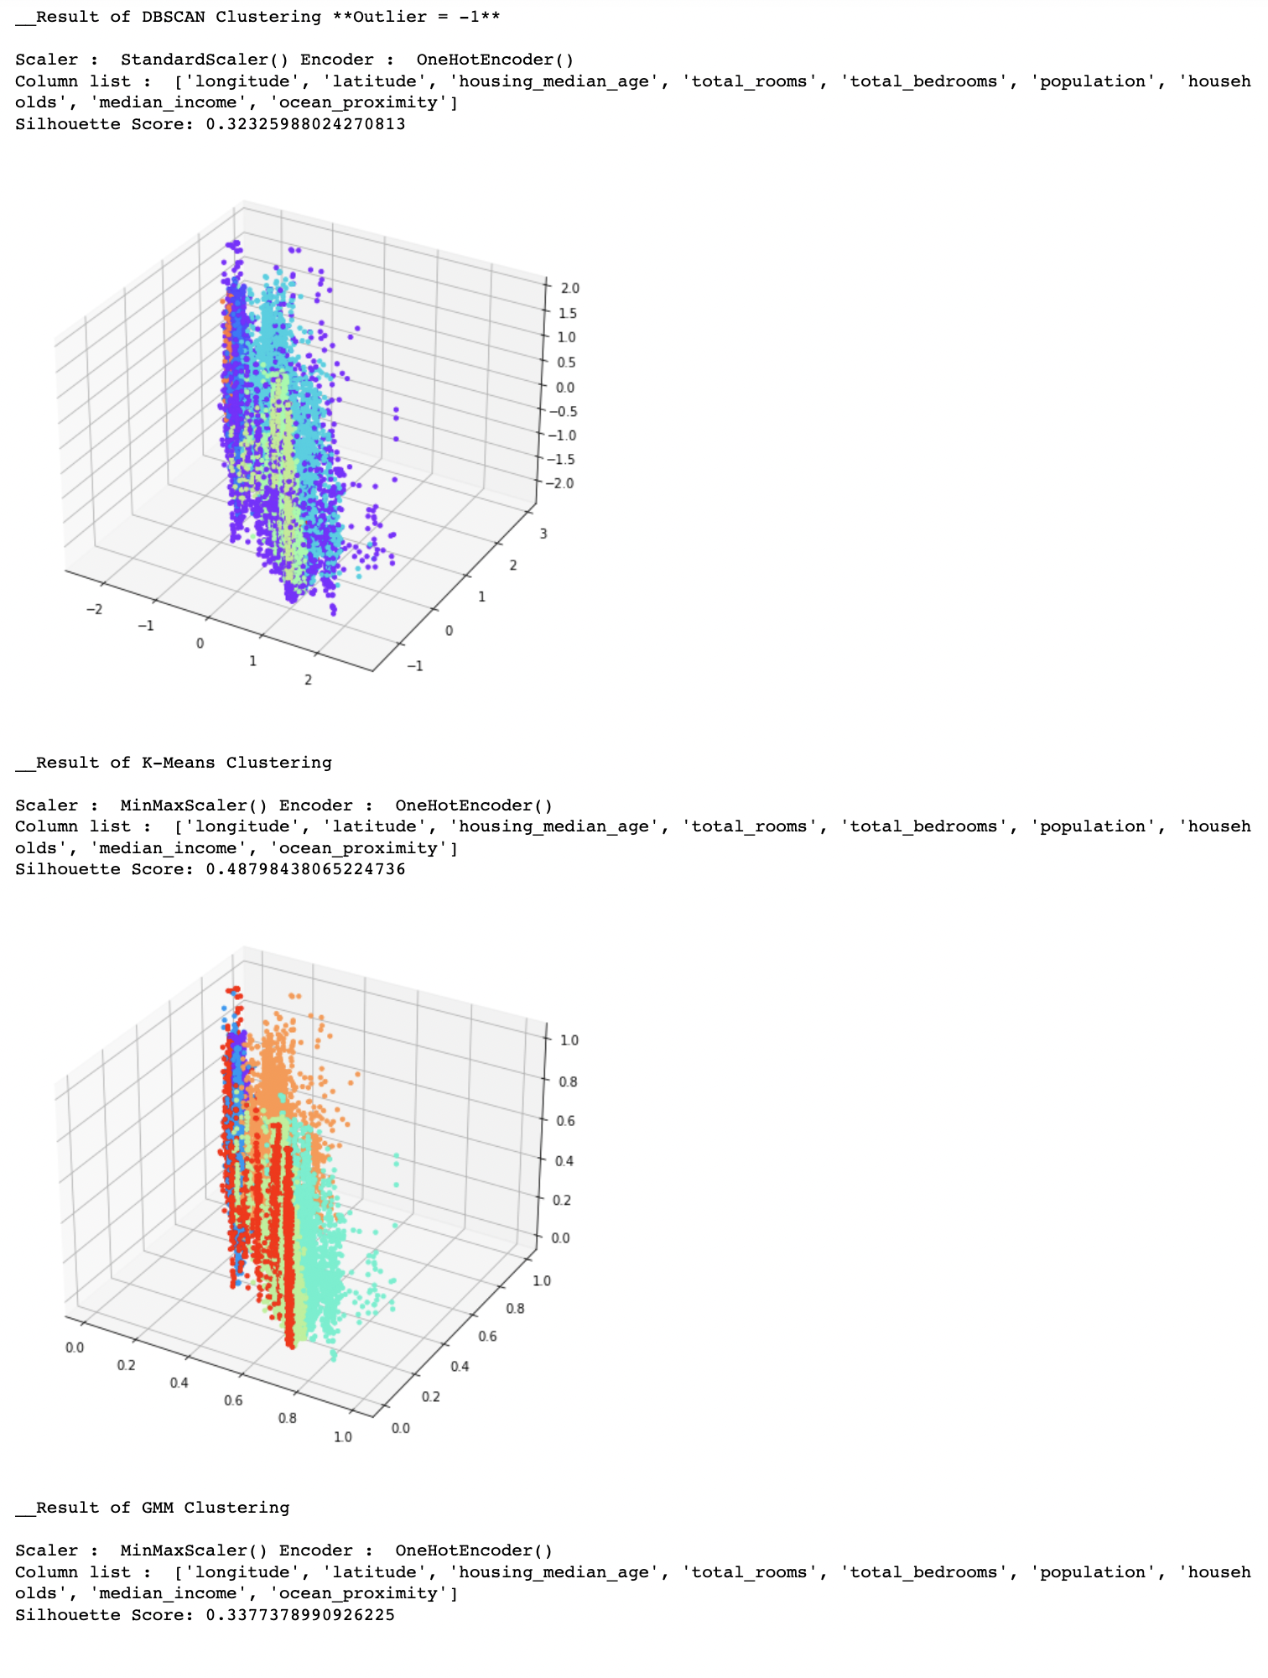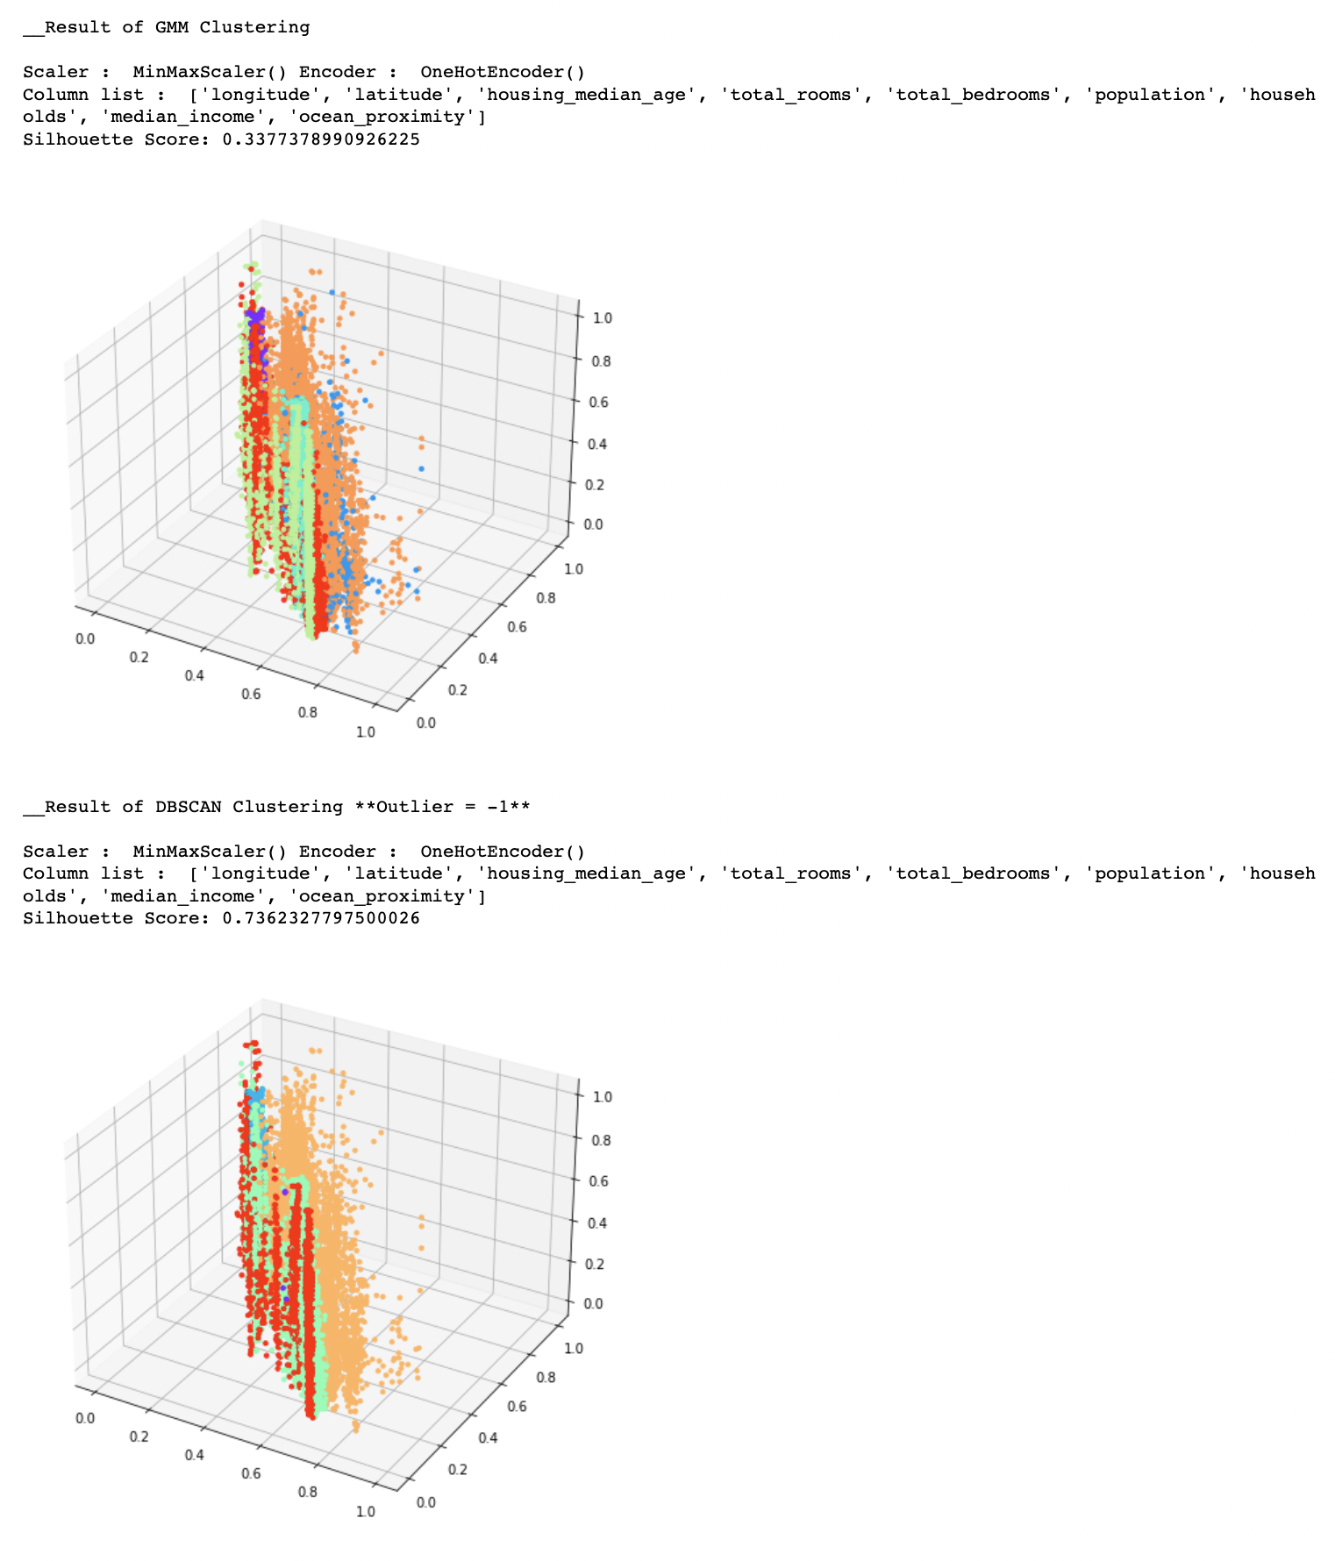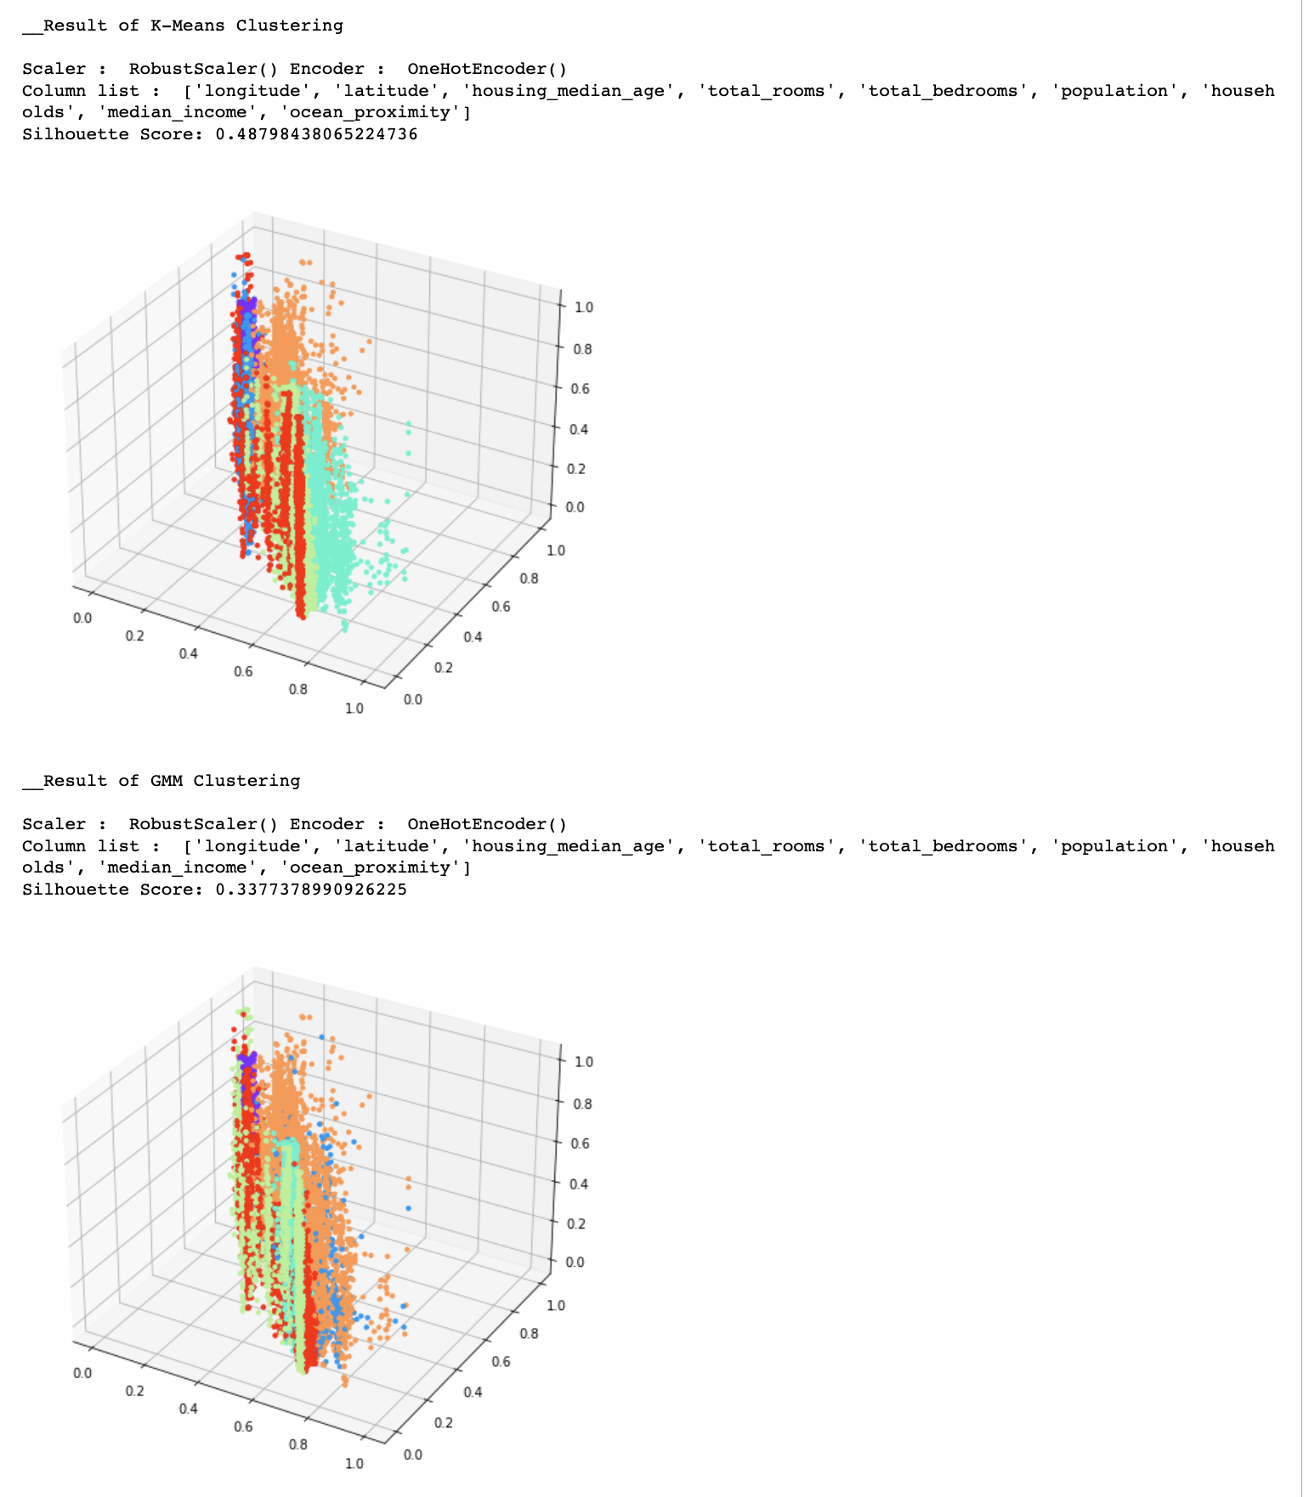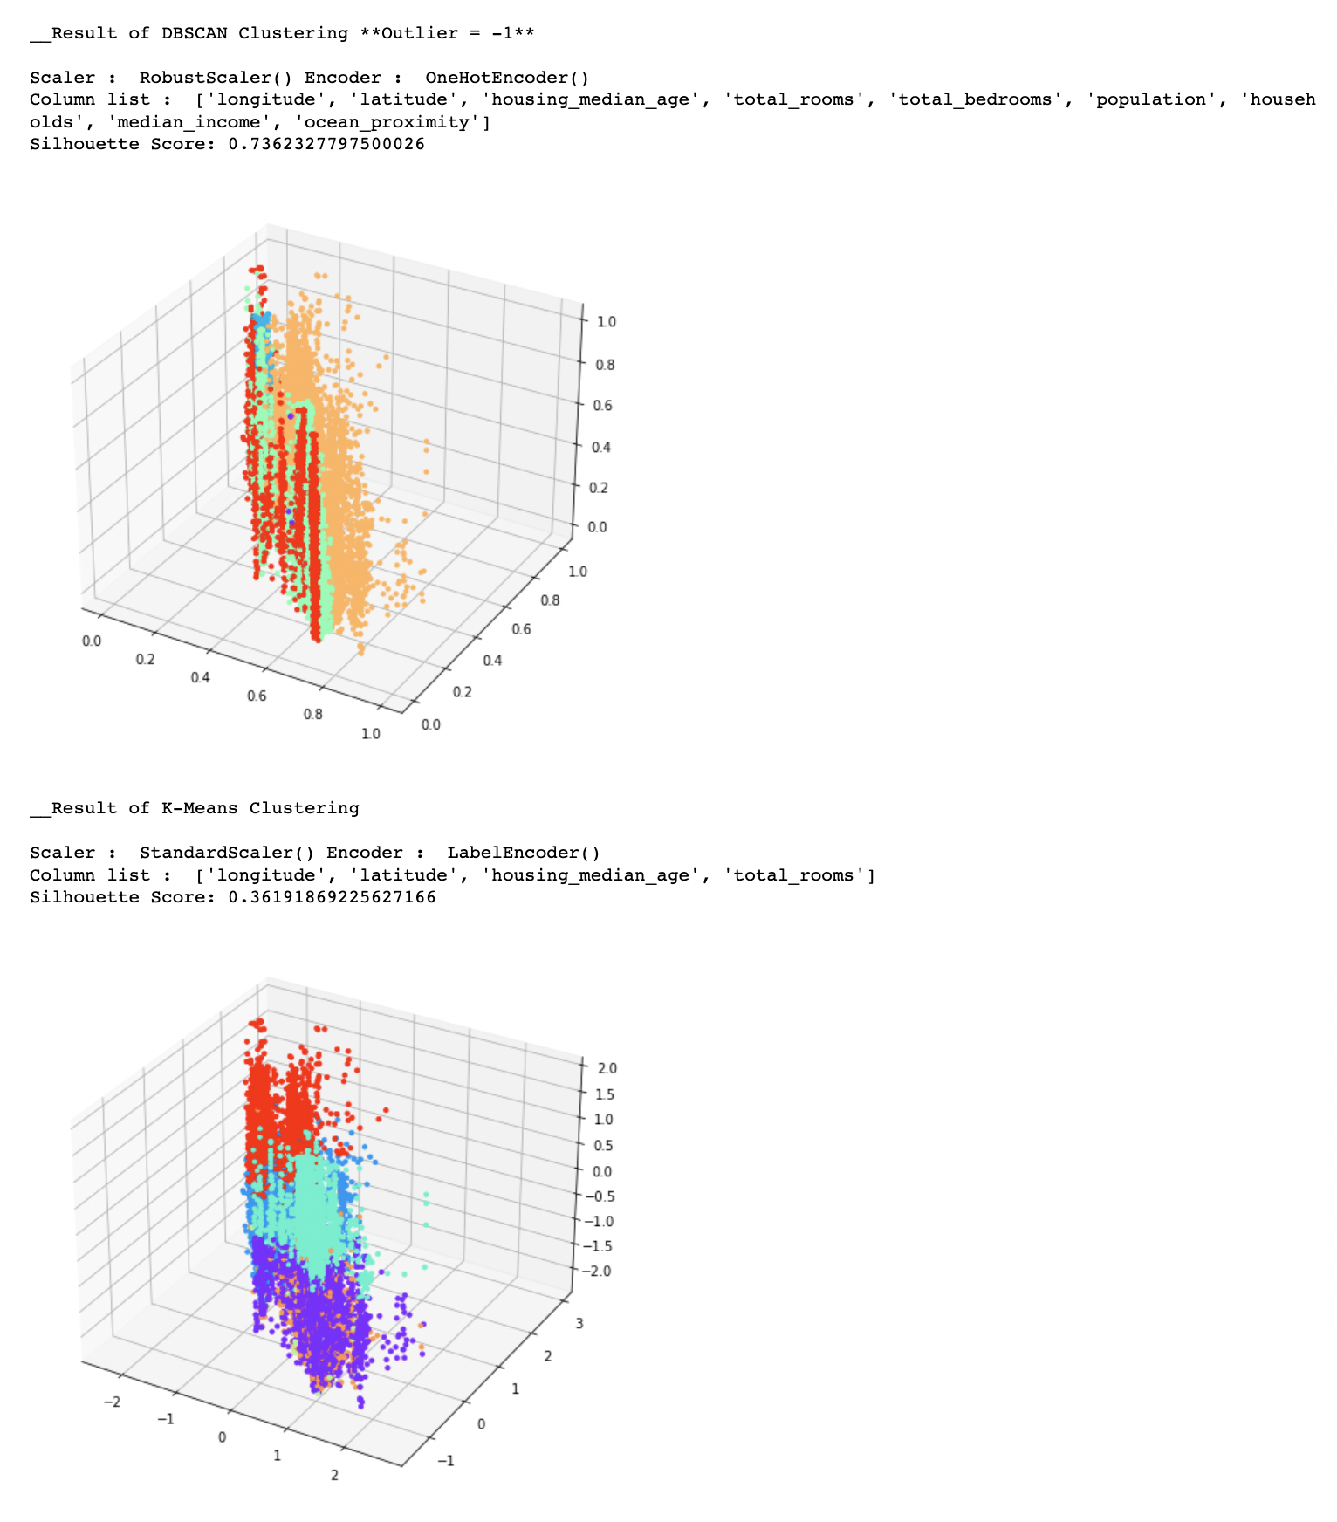

# 

# 5. Conclusion

1. The best representation of the dataset, and the appropriate combination is "**DBSCAN with LabelEncoding, StandardScaling, Epsilon = 0.4, Threshold = 15**".

(The silhouette score = 0.036028042807949204)

1. It seems this combination has the best performance because LabelEncoding encodes unstructured data into continuous figures and clusters them with DBSCAN, a density-based clustering algorithm.
2. For the same reason, standard scaling seems to be strong in density-based clustering because all features have the same scale.
3. The reasons why we thought clustering was not easy are as follows.
   1. It is difficult to determine the number of clusters in a dataset.
   2. The combination of scaler, encoder, and model is so diverse that it is difficult to find a suitable one because of the large number.
   3. When selecting various features, it is not easy to grasp the quality of the cluster even if expressed in plot or 3D.

Contribution

*Each members wrote their own programs first, then we verified the best part and integrated it into one program.*

|  |  |  |  |
| --- | --- | --- | --- |
| **Percentage** | | | |
| **안해빈** | **윤주은** | **이지민** | **임윤수** |
| **25%** | **25%** | **25%** | **25%** |